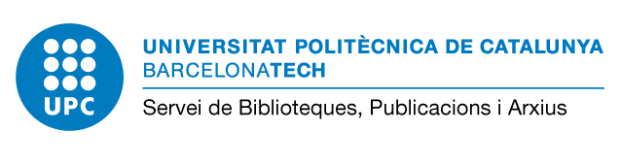
Data Management Plan's initial description (PID 2025)
Explain the purpose of the data collection/generation and the relation of the data collected or generated to the objectives of the project and specify:

- Types of data (observational, experimental, simulation...), format (text, numeric, image, etc.) and estimated size.

Example: The project data consists of observational information obtained from interviews with participants. Data will be recorded in open formats such as text files (.txt) or spreadsheets (.csv).

- Source of the data. Data generated within the project and/or data collected (reuse existing data). Indicate the source from which data will be obtained.

Example: The data will be generated exclusively within the project through interviews conducted by the research team. No third-party data will be used. All participants will provide informed consent before the interviews.

- Repository where the data will be stored

Example: Once the project will be finished, datasets is finished in CORA. Research Data Repository (RDR), repository of research data of the Catalan universities and the CERCA centers, which follows FAIR principles (Findable, Accessible, Interoperable, Reusable). All datasets shared publicly will be anonymized to protect participant identities. A unique identifier (DOI) is provided to each dataset.

- In the case of data that is subject to personal data protection regulations or ethical considerations, please indicate how it will be managed

Example: The data collected during the project constitute personal data and will be managed in accordance with GDPR and ethical standards. Access to raw data will be restricted to project researchers. Any data shared publicly will be anonymized to protect participant identities.

November 2025

