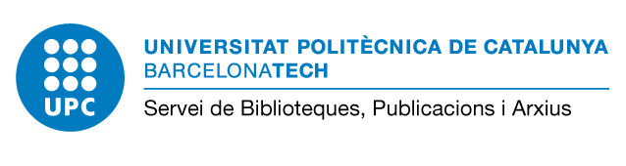

Data Management Plan - Convocatòria 2020 «Proyectos de I+D+i»

Document with the basic information regarding the DMP to be incorporated into the report

Typology and format of data

Explain the purpose of the data collection/generation and the relation of the data collected or generated to the objectives of the project.
Research data is generated for different reasons through different processes and can be of the following type (observational, experimental, simulation...). The format of the data (text, numeric, image, etc.) should also be indicated.

Specify the source of the data

Data generated within the project
Data collected: Indicate the source from which data will be obtained
Reuse existing data

Access to data

Specify how the data will be accessed: Describe how the data will be shared, who will access the dataset.

Specify where data, metadata, documentation, and code are deposited: Indicate the repository in which data, metadata, documentation, and code will be stored. It can be in the same repository or in different depending on the content type.

It is important to use repositories that provide data with permanent links (DOI, Handle) to facilitate discovery and citation.
Example for depositing datasets in the repository: Once the project will be finished, datasets will be published in UPCommons ResearchData, the UPC institutional repository which follows FAIR principles (Findable, Accessible, Interoperable, Reusable). In the repository, a handle and a DOI will be provided to each dataset. In case of very large datasets, DataverseCAT will also be used.

Ethical or legal problems that may affect data collection and exchange

Describe potential ethical problems during data collection, storage, processing, and reporting, along with the ethical approval procedures related to the project.

If research activities involve children, patients, vulnerable populations, embryonic stem cell use, privacy issues and data protection or research in animals and primates, ethical principles must be met and relevant national legislation both the European and international legislation.

Example: The project will not create, process and store personal data. In addition, the fundamental principles of research integrity will be respected.

